Executive Summary

Results

-Proportional Control - Performance Analysis, Benchmarking, Establishing Performance

1. For a system under proportional control, it was observed that as *Kop*is increased from 0 to *Kcrit*, the steady state error percent decreases. This is because $K_{pos}=\lim_{s→0}G_{open}(s),$ and for a proportional control system, $G_{open}(s)$ is proportional to *Kop*. The steady state error for a step input can be determined by $e_{ss(step \%)}= \frac{1}{1+K_{pos}}*100\%,$ so from this equation, it is clear that if $K_{pos}$ increases, the steady state error will become smaller. As you reach *Kcrit*, the overall system approaches marginal stability, and the system no longer has a steady state. Increasing the value of *Kop* even further will push the system into instability.
2. For a system under proportional control, it is observed that as *Kop*is increased from 0 to *Kcrit*, the steady state error percent decreases. This is because $K_{v}=\lim_{s→0} s *G_{open}(s),$ and for a proportional control system, $G_{open}(s)$ is proportional to *Kop*. The steady state error for a ramp input can be determined by $e_{ss(ramp )}= \frac{1}{K_{v}},$ so from this equation, it is clear that if $K_{pos}$ increases, the steady state error will become smaller. As you reach *Kcrit*, the overall system approaches marginal stability, and the system no longer has a steady state. Increasing the value of *Kop* even further will push the system into instability.
3. PO increases as K increases. $PO = 100*e{}^{\frac{-ζπ}{\sqrt{1-ζ^{2}}}}$

Settling Time (2%) increases as K increases.

Rising time *Trise(0-100%)* decreases as K increases.

1. Plot of 3 values of K for comparison

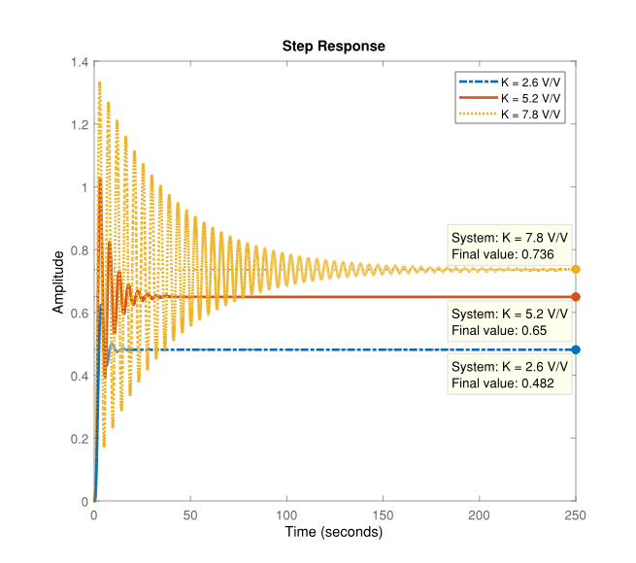

**Figure _.**

**Table 1.** System Under Proportional Control

|  |  |  |  |  |  |
| --- | --- | --- | --- | --- | --- |
| Operating Gain | Percent Overshoot  PO | Settling Time  Tsettle(2%) | Rise Time  Trise(0-100%) | ess(step%) | ess(ramp) |
| Low = 2.6 | 30% | 10.2 | 2.52 | 51.8% | ∞ |
| Med = 5.2 | 57.9% | 23.3 | 2.02 | 35% | ∞ |
| High = 7.8 | 81.4% | 147 | 1.76 | 26.4% | ∞ |

$$G_{cl}(s) = \frac{1.43K}{s^{4}+ 5s^{3} +10s^{2} +10s + (4+1.43K)}$$

$$G{}_{cl}(s) = \frac{1.43K}{s^{4} + 5s^{3} +10s^{2} +10s + (4+1.43K)}$$

**Table 2.** Benchmarking at Quarter Decay Response

|  |  |  |  |  |  |  |
| --- | --- | --- | --- | --- | --- | --- |
| System Controller Type | Operating Gain,Kop | Percent Overshoot,  PO | Settling Time,  Tsettle(2%) | Rise Time,  Trise(0-100%) | ess(step%) | ess(ramp) |
| Proportional | 3.68 | 42.2% | 14.5 | 2.26 | 43.2% | ∞ |

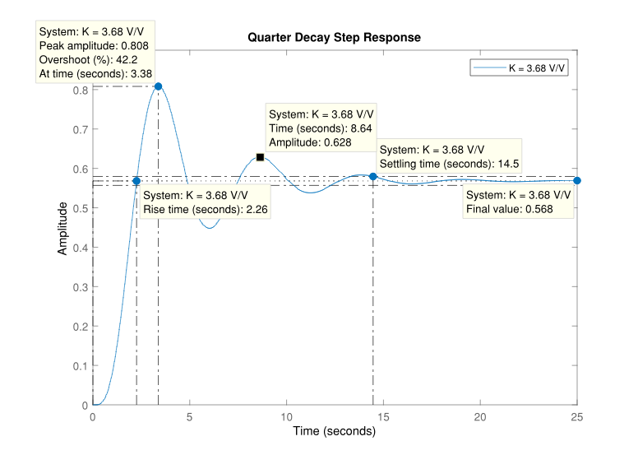

**Figure _.**

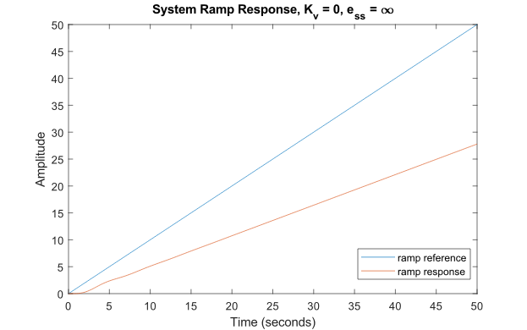

**Figure _.**

-Proportional + Integral Control - Performance Analysis

1. As K increases and the 𝜏i is held constant, the settling time(2%) increases, PO increases, rise time (0-100%) decreases. For a system under PI control, it was observed that if the proportional gain, K, is set too low, there will be no overshoot.

As 𝜏i increases and the proportional gain is held constant, the settling time(2%) increases. However, as 𝜏i becomes very small, the settling time starts to increase as well and at some point, if it is reduced even further, the system will approach instability. As 𝜏i increases, PO decreases, and rise time (0-100%) decreases. Unlike the proportional gain, there will always be a slight percentage overshoot, infinitesimally small but still greater than 0, regardless of how much the time integral constant is changed.

The reason for this is because as the time constant decreases, the number of oscillations starts to decrease as well. When there is no more oscillations in the system, decreasing the time constant further will only slow down the system and make it take longer to reach steady state.

**JUSTIFY THIS WITH EQUATIONS/THEORY WHENEVER**

1. Compare performance of PI system with benchmarked response for P system. Save “some” samples of PI system responses.

**Table 3.** Proportional Integral controller specifications

|  |  |  |  |  |  |  |
| --- | --- | --- | --- | --- | --- | --- |
| Operating Gain, Kop | Integral Time Constant, 𝝉i | PO  (%) | Settling Time,  Tsettle(2%) | Rise Time,  Trise(0-100%) | ess(step) | ess(ramp) |
| 2.1 | 5 | 0 | 34.4s | 60.17s | 0 | 6.66 |
| 5.2 | 5 | 27.8 | 27.2s | 2.6s | 0 | 2.69 |
| 7.0 | 5 | 52.2 | 206.7s | 3.0s | 0 | 2.00 |
| 2.1 | 2 | 3.4 | 9.4 | 4.7 | 0 | 2.66 |
| 2.1 | 8 | 0 | 57.5 | 109.7 | 0 | 10.66 |

The benchmarked performance for the Proportional control system can be improved by including an integral component into the system. As shown by the performance responses for the Proportional Integral control system at different operating gains and integral time constants in **Table 3**, an integral component will always reduce the steady state error to 0 for a step input. The steady state error for a ramp input will start to approach 0 as the time constant is decreased or the gain is increased, but we cannot increase the gain too much as it will affect the percent overshoot of the system. To reduce the 42.2% percent overshoot of the benchmarked P system to less than 15% using a PI system, the selected operating gain can be decreased and the integral time constant can be increased. However, it should be noted that by increasing the integral time constant, the rising and settling time are increased significantly. If we want to also ensure that the settling time, Tsettle(2%) , is less than or equal to half of the benchmarked P system’s settle time of 14.5 seconds, then the integral time constant should be decreased and the gain should be decreased accordingly so that the percent overshoot specification is also met. However, from our comparison of different gains and time constants for the PI system, the settling time was unable to be reduced to half of the benchmarked system’s settling time.

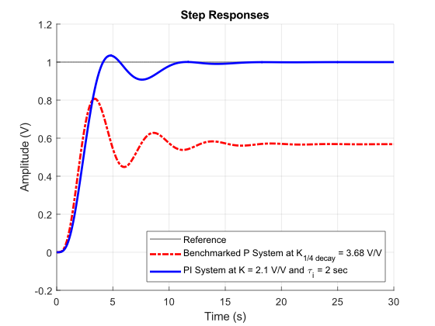

**Figure _.**

**Figure _** above shows a possible improvement to the benchmarked P system response using a PI control system. The parameters and specifications for the PI system are recorded in the 4th entry (row) of **Table 3**. It is possible to meet most of the desired performance specifications, except for settling time. If the integral time constant is decreased even further, the system would start to slow down with an increase in settling times. The only issue with the PI control system seems to be the speed of the system; it can either have a fast rise time with lots of oscillations, resulting in a slow settling time, or it can have a slow rise time with very little oscillations, resulting in a faster settling time.

-Proportional + Derivative Control - Performance Analysis

Repeat what was done for PI control #1

1. As K increases and the 𝜏d is held constant, the settling time(2%) increases, PO increases, rise time (0-100%) decreases. For a system under PD control, it was observed that if the proportional gain, K, and the derivative constant are set too low, there will be less overshoot.

**JUSTIFY WITH EQUATIONS/THEORY WHENEVER**

1. Repeat what was done for PI control #2

**Table 4.** Proportional Derivative controller specifications

|  |  |  |  |  |  |  |
| --- | --- | --- | --- | --- | --- | --- |
| Operating Gain, Kop | Derivative Time Constant, 𝝉d (s) | Percent Overshoot (%) | Settling Time,  Tsettle(2%)  (s) | Rise Time,  Trise(0-100%)  (s) | ess(step) (%) | ess(ramp)  () |
| 2.1 | 2 | 45% | 6.3 | 1.4 | 57.1 | ∞ |
| 5 | 2 | 67.1% | 12.8s | 1.2 | 35.9 | ∞ |
| 7 | 2 | 78% | 22.9s | 0.9 | 28.6 | ∞ |
| 2.1 | 5 | 118.3% | 12.6s | 0.9 | 57.1 | ∞ |
| 2.1 | 8 | 176.1% | 18.0s | 0.7 | 57.1 | ∞ |

1. Repeat what was done for PI control #3

The benchmarked performance for the Proportional control system can be improved by including a derivative component into the system. As shown by the performance responses for the Proportional Derivative control system at different operating gains and derivative time constants in Table 4, a derivative component will not change the step steady state error or reduce the ramp steady state error to 0 for any value of the time constant. If the derivative time constant is reduced along with the gain then the percent overshoot is reduced but not less than the desired percent overshoot of 15% and the settling time approaches half of the bench marked value. However, the issues here are that reducing the gain will increase the step steady state error and reducing the derivative component will increase the rise time.

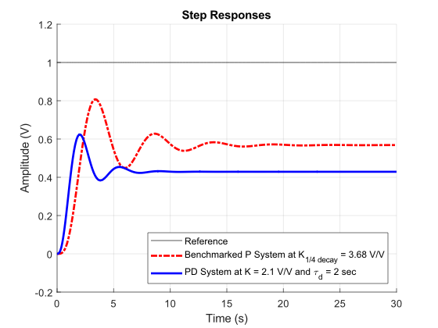

**Figure _.**

**Figure _** above shows a possible improvement to the benchmarked P system response using a PD control system. The parameters for the PD system are recorded in the 1st entry (row) of **Table 4**. It is not possible to meet most of the desired performance specifications for the system, except for settling time. If the derivative time constant and gain is decreased even further, the percent overshoot can be reduced more, but they cannot be decreased past 0 or the system will become unstable. The issues with the PD control system for our given system is that the steady state errors will always be present in the system even if the system responds very quickly.

-Proportional + Integral + Derivative (PID) Control - Design

Objective:

Performance specifications (that we want to achieve with PID controller design):

* + ess(step)% = 0
  + ess(ramp) approach 0,
  + PO less than 15%
  + Tsettle(2%) to be less than or equal to half of the benchmarked P system’s settle time

Find “best” PID controller settings (K, tau_i, tau_d) to improve benchmarked P system

Show how theory learned in the course was applied in our design approach

Show how large of an improvement was made to the benchmarked P system using the PID system.

**Table 5.** System performance comparison

|  |  |  |  |  |  |
| --- | --- | --- | --- | --- | --- |
|  | Desired Performance Specifications | Simulated Performance Specifications | | | |
| Controller  Type | P, PD, PID | Proportional | PID | | |
| Kp= 3.68  Pu = 5.2174 | Kp = 3.68  Pu = 5.2174 | 𝝉i = 3.478 | 𝝉d = 0.870 |
| Percent Overshoot,  PO (%) | ≤ 15 | 42.2 | 0 | | |
| Settling Time,  Tsettle(2%) (s) | ≤ 7 | 14.5 | 13.8 | | |
| Rise Time,  Trise(0-100%) (s) | N/A | 2.26 | 5.76 | | |
| ess(step) (%) | 0 | 43.2 | 0 | | |
| ess(ramp) (%) | ⟶ 0 | ∞ | 2.64 | | |

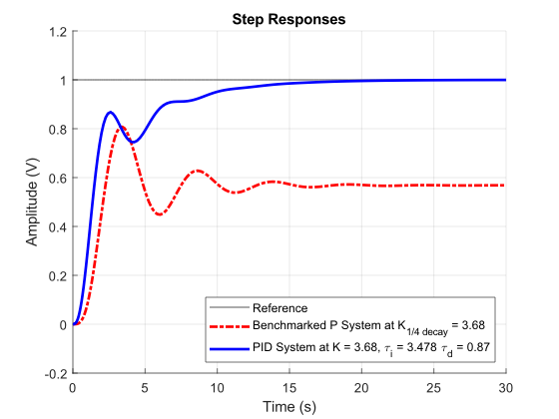

**Figure _.**

Ziegler-Nichols “Ultimate Gain” PID tuning modified method was used in order to determine the parameters for the PID system in **Figure _**. The integral and the derivative modes were first disabled so that the proportional only mode remained. Then the system was set to the quarter decay value of the proportional gain obtained in the benchmarking in part 1 of this lab and this ;;;’value was denoted as the ultimate gain. The period of the oscillations from the system’s response at this ultimate gain was recorded. Then the integral and the derivative time constant were determined by applying their respective equations for the modified method:

Pu = 5.2174 s (from the Quarter decay response in **Figure _**)

$$τ_{i}=\frac{P_{u}}{1.5}=\frac{5.2174}{1.5}=3.478 s$$

$$τ_{d}=\frac{P_{u}}{6}= \frac{5.2174}{6}=0.87 s$$

Discussion

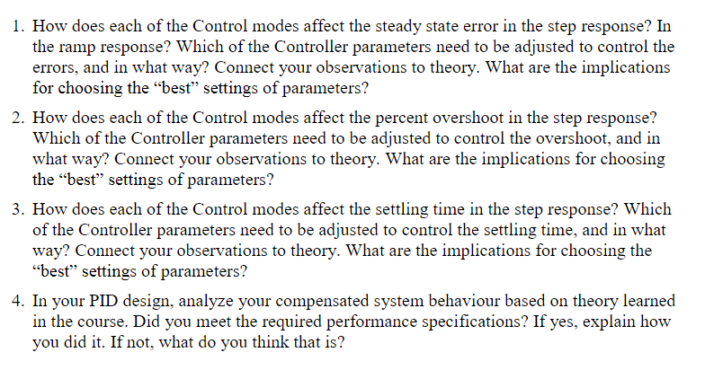

1.

[Which parameters need to be adjusted to affect ess(step and ramp). Connect observations to theory]

The implication for choosing the “best” settings of parameters is related to the ramp steady state error. This is because we have no control over the parameters that affect the ramp error. There is no implication in terms of the step steady state error since the error is always zero regardless of the chosen parameters, as observed in part 1.

2.

From our observations of the PI and PD systems in part 1, we found that the integrator component of the PI system generally caused the PO to be less than that of the benchmarked P system. On the other hand, the derivative component of the PD system generally caused the PO to be higher than that of the benchmarked P system. For the PID controller, the gain of the controller, as well as the derivative time constant, are proportionally related to the PO, whereas the integral time constant is inversely proportional to the PO.

PI control adds an extra pole to the system, and if the location of the pole is close enough to the existing poles, it will have a noticeable effect on the system. The impact of this pole will be a slower system in terms of rise time, but it will also have reduced PO and smaller oscillations. If the pole is very close to the imaginary axis, it may become the dominant pole and, in this case, the response would be exponential, resulting in very slow rise and settling times, as well as no PO since there will be no oscillations. PD control adds an extra zero to the system, and if the location of the zero is close enough to have a non-negligible effect, the PO will be higher, but the rise time will be much faster.

The implications for choosing the “best” settings of parameters is that all the parameters that affect the PO will be fixed depending on the quarter decay gain of the given system, meaning that adjusting one parameter would require adjusting all the other parameters. That means that depending on the specifications that the tuning method was designed for, it may be not very relevant or application to all systems. For our desired PO requirement of less than 15%, the parameters obtained from the tuning method was applicable.

3. From our observations of the PI and PD systems in part 1 we found that the integrator component of the PI system decreases the settling time as the time constant decreased and the derivative component of the PD system decreases the settling time as the time constant decreased. Selecting low integral and derivative time constants causes the rise time to increase and the percent overshoot to increase.

[Which parameters need to be adjusted to affect settling time. Connect observations to theory]

In terms of settling time, we can clearly see the implications of choosing the “best” settings of parameters. While these settings improved the performance of the overall system, the settling time was not improved much. This shows that the goal of the tuning method was not to speed up the system response, but it was to eliminate steady state errors and percentage overshoots overall.

4.

$Tsettle(2\%) =4/ζwn$ $PO = 100*exp(-ζπ/\sqrt{1-ζ^{2}})$ $Trise(0-100\%) =\frac{π-cos^{-1}ζ}{wn\sqrt{1-ζ^{2}}}$ $α = ζwn$

$τ =1/ζwn$ $wd =wn\sqrt{1-ζ^{2}}$ $cos φ = \frac{α}{wn}= ζ$ $ess(step) = \frac{1}{1+ Kpos}$ $ess(ramp) = \frac{1}{Kv}$

References